**Path Sum:**

Given the root of a binary tree and an integer targetSum, return true if the tree has a **root-to-leaf** path such that adding up all the values along the path equals targetSum.

A **leaf** is a node with no children.

**Example 1:**

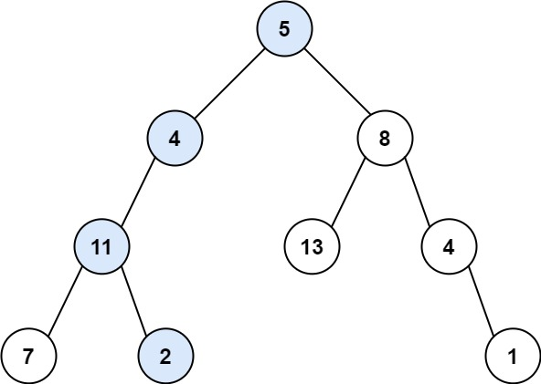

**Input:** root = [5,4,8,11,null,13,4,7,2,null,null,null,1], targetSum = 22

**Output:** true

**Example 2:**

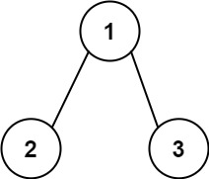

**Input:** root = [1,2,3], targetSum = 5

**Output:** false

**Example 3:**

**Input:** root = [1,2], targetSum = 0

**Output:** false

**Constraints:**

* The number of nodes in the tree is in the range [0, 5000].
* -1000 <= Node.val <= 1000
* -1000 <= targetSum <= 1000

s